Building WhatsApp for illiterate and digitally challenged

***Author*** *Avinash Singh*

***Change history*** *Version 1.0  
May, 21 2022, First Draft*

***Objective***Building WhatsApp for illiterate and digitally challenged people to let them communicate with anyone and anywhere in the world without any barriers.

***Why build WhatsApp for the illiterate and digitally challenged? The Construct***Along with smartphones, our life is getting easy day by day and WhatsApp is one of the basic and important apps for our day-to-day life. Everyone is now using WhatsApp to communicate, either to text or do some video calls. Many companies also prefer to give updates about their products on WhatsApp. Most of the world is moving forward, but there is a big chunk of the world population lagging behind - the people who are illiterate. According to UNESCO, “there are still 773 million illiterate adults around the world.” It’s small in percentage but huge in number. Various NGOs and organizations are working to make this number zero. Meanwhile, we can try to help them by design thinking and reducing their daily life technical challenges by building WhatsApp for them.

***Assumption***We assume that the person who is going to use this is illiterate and digitally challenged. This app is not for those who have some kind of disability that prevents them from reading and writing in any language, e.g., visual impairments, learning disorders. These people are not using WhatsApp for business purposes but only for personal purposes.

***What is the core need?***WhatsApp is not only for chatting purposes but several tasks are a basic necessity for day-to-day life in every common person, like sending a document, sending a current location, and doing a video call.

***User Stories***To understand the needs of real users, I have surveyed 4 people aged between 20 to 50 who try to use a smartphone but often fail due to their illiteracy. However, they can easily do some work with their mobile like:

* Calling someone by dialing a number and all of them also use speed dial.
* Identifying contacts by photos.
* Understanding the icons of some apps like YouTube, calls, and messages.
* Finding WhatsApp UI confusing.
* Learning smartphone use if taught once, and they can do a few tasks easily like watching videos, clicking photos, etc.

***User Persona******Name****: - Shlok****Age****: - 27****Location****: - Bangalore****About****: -* Shlok was born in Madurai, Tamil Nadu. He is now working at Zolo in Bangalore as a caretaker. He never attended any school or any formal education and doesn’t know how to read and write.

***Digital experience****: -* Shlok is an experienced smartphone user. He uses his smartphone to watch videos on YouTube and also makes calls.***Pain Points:-***

* Difficulty in understanding text messages due to language illiteracy.
* Difficulty operating the app features due to digital illiteracy.
* Difficulty with touch as icons are usually small.
* The lack of knowledge of the language is the primary barrier to using WhatsApp.

***The Product solution******Audio-based UI****: -* Audio icon after every heading or subheading, where it explains the meaning of that heading/icon. A speaker button will be provided along with every heading or subheading and icons so that the user can understand what it is.

***Minimal UI with big icons****: -* Decluttering unnecessary elements from the UI will help the user not to be confused or distracted. Using big signs for icons like chat, call, etc., will make the user understand the function easily.***Tutorial section****: -* A tutorial section will always be there to help out the user.***Text to speech****: -* Using Google text-to-speech instead of the on-screen keyboard to write easily.

***Help button****:* Help button on all screens to give a tutorial of that particular screen's options.

***Using photos in place of Icons****: -* Well-designed photos are better than icons and easy to understand for any person.

***The primary chat option is voice, secondary is text chat****: -* Voice chat is more useful for illiterate people as it is easy to express in less time, which is why making voice chat the primary chat option.

***UPI option****: - Option to send and receive money easily.*

***Evaluating trade Off***

|  |  |  |  |
| --- | --- | --- | --- |
| **S NO** | **Priority** | **Feature/Requirements** | **Impact** |
| 1 | 2 | Audio-based UI | High |
| 2 | 3 | Minimal UI with big Icon | High |
| 3 | 1 | Tutorial Section | High |
| 4 | 5 | Text to Speech | Medium |
| 5 | 4 | Help Button | Medium |
| 6 | 7 | Using a photo in place of the icon | Low |
| 7 | 6 | The primary chat option is the voice and the secondary is chat. | Medium |
| 8 | 8 | UPI Option | Low |

Observing the priority, in this version only features with Priority 1, 2, 3, 4, and 5 will be implemented as these features are easy to build and have a high impact in the majority of use cases.

***Wireframes*** *Its features are broadly elaborated in the wireframes.*

**Low fidelity wireframe-1**

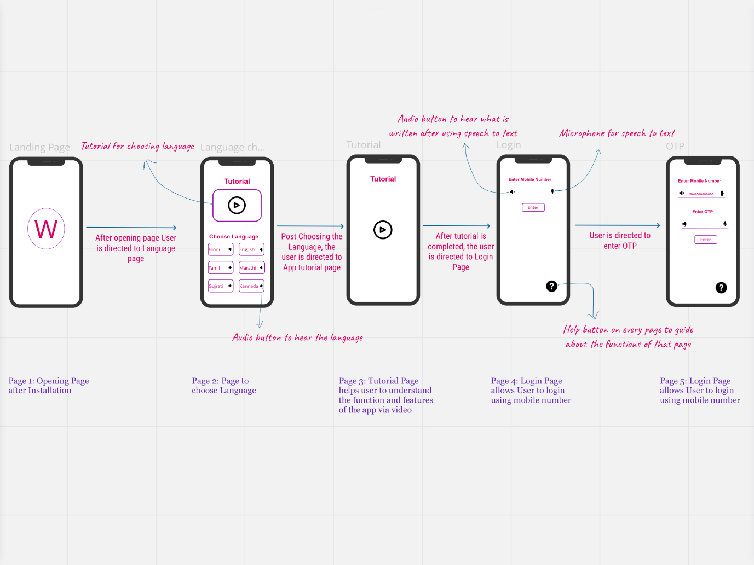

**Low fidelity wireframe-2**

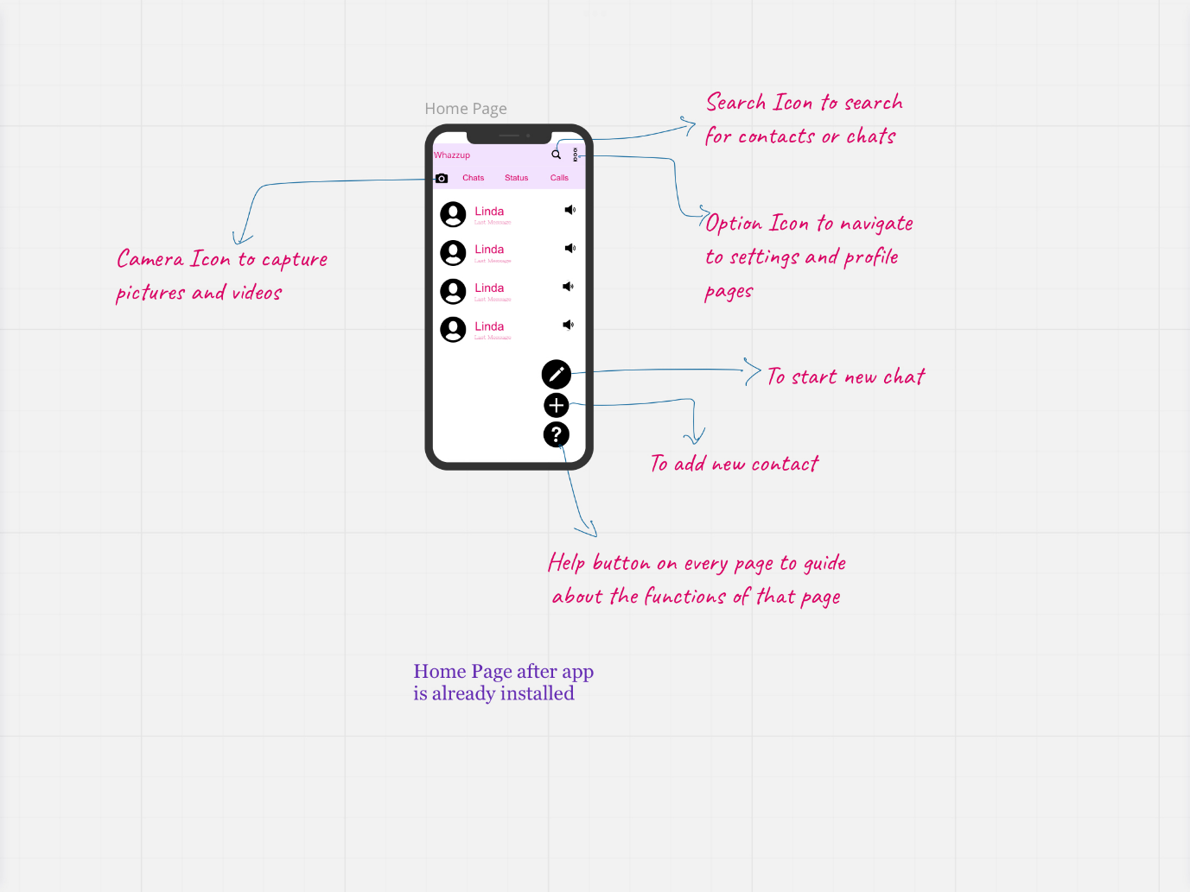  
  
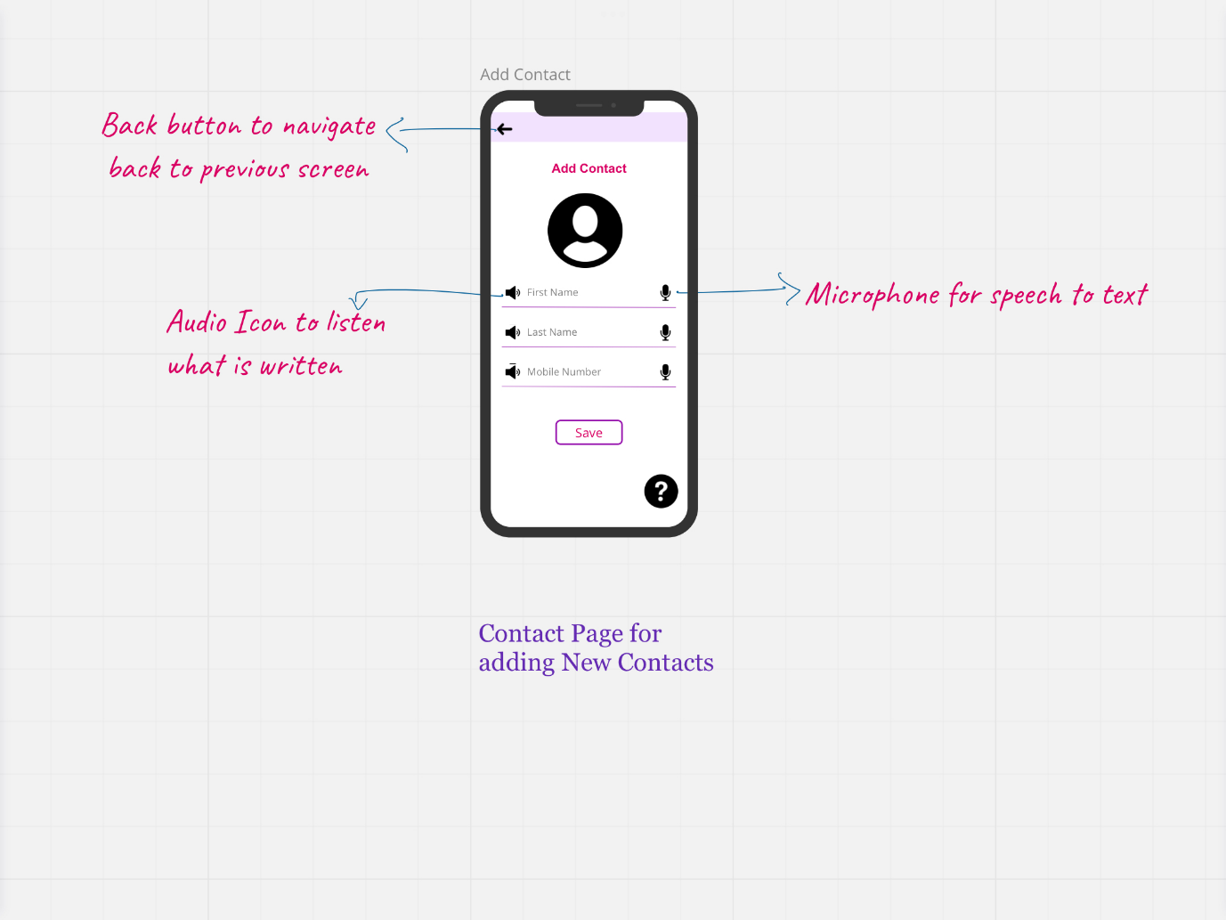  
  
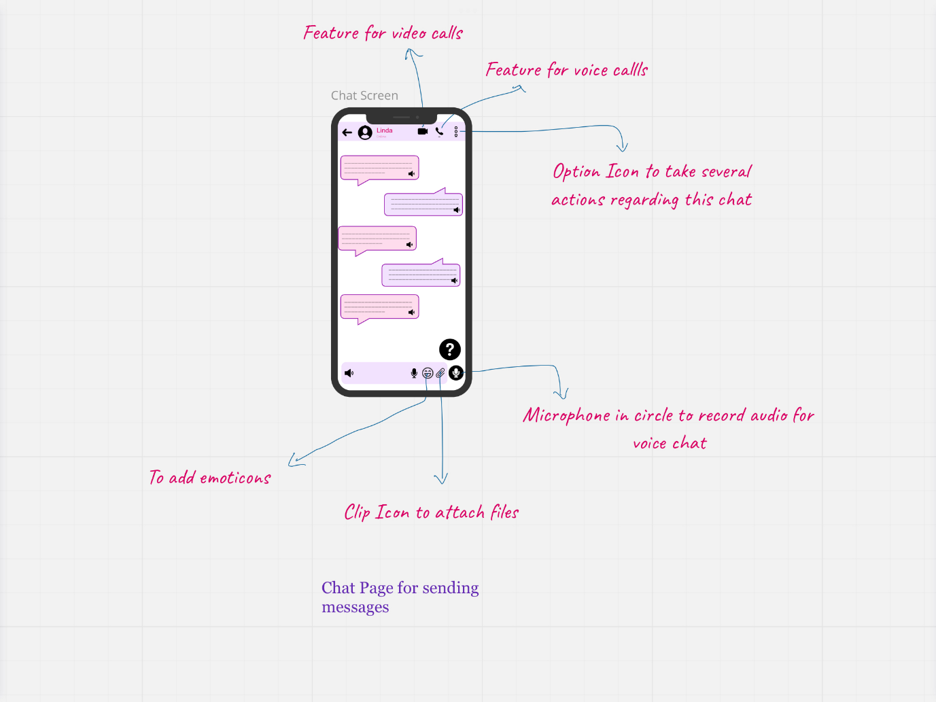  
  
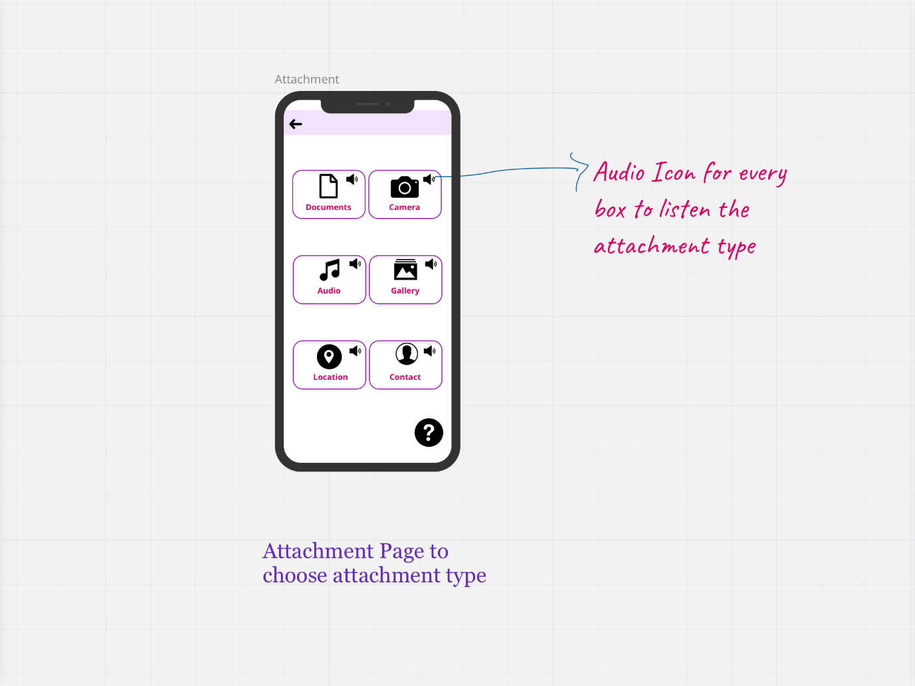  
  
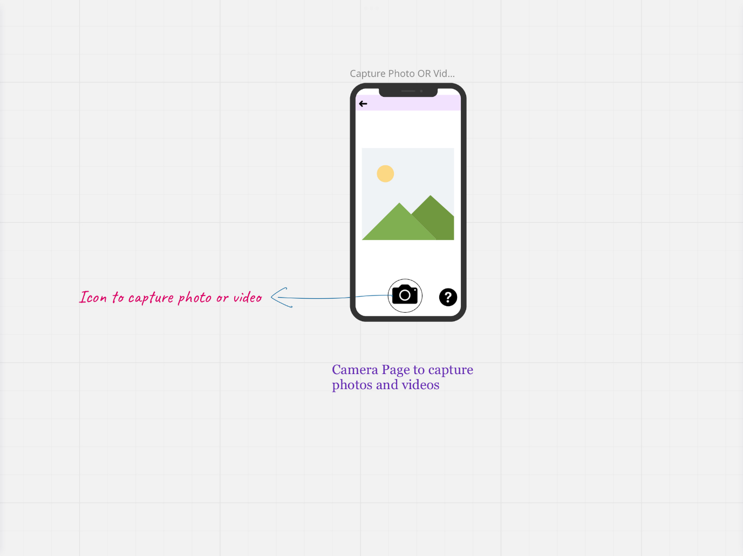  
  
  
  
**Key Metrics**

Key metrics for measuring the success of the features implemented:***North star metrics:***

1. Number of tutorials watched.  
2. Number of messages sent through this platform.  
3. Number of images shared per user.  
4. Average time to share an image.  
5. Number of voice and video calls made on this platform.

**Secondary metrics:**

6. Number of Daily Active Users (DAUs)  
7. Number of Monthly Active Users (MAUs)

***Open Issues*** *NA****Q&A*** *NA*